The Acorn Restaurant
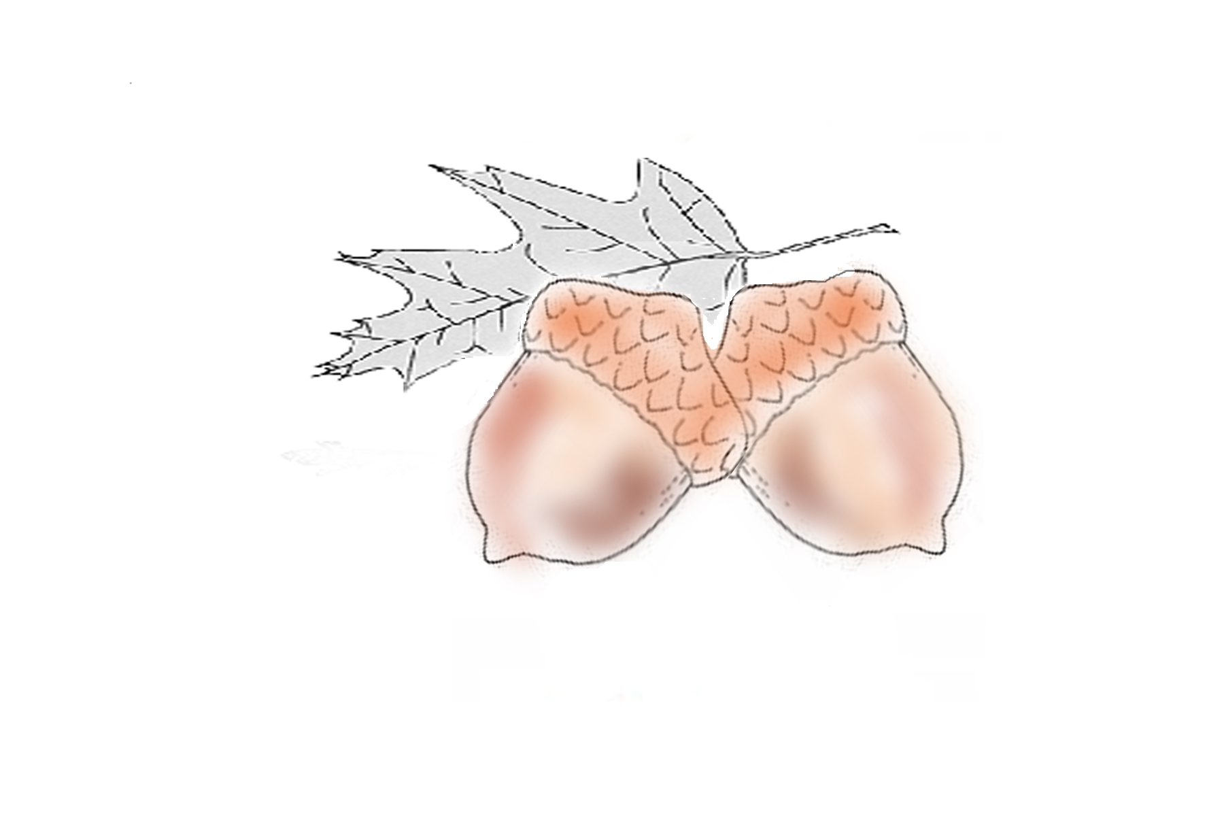
Dinner Menu
Served 5:00pm to 8:30pm
Price Includes Drink (coffee, tea, or soda)

Appetizers
All appetizers served with your choice of two sauces. Additional sauces $0.35
Buffalo, Texas Pete, Hollandaise, Marinara, Ranch, Honey Mustard, Blue Cheese

Chicken Wings(6) $5.95
Lightly seasoned wings with your choice of sauce.
French Fries $3.95
Our locally famous hand-cut potato chips sprinkled with our special seasoning.
Mozzarella Sticks (8) $5.95
Fried Mushrooms $4.95
Chicken Fingers (4) $5.95
Tender chicken tenderloin breaded and fried.
Jalepeno Poppers(6) $5.95
Mild Jalapenos stuffed with cheddar cheese in a crispy breading.
Acorn Cakes (4) $4.95
A house specialty and southern favorite… these fried grits are a definite must!
Celery & Carrot Sticks $2.95
Onion Rings $4.95

Salads
Dressings: Ranch, Balsamic Vinaigrette, Blue Cheese, or Honey Mustard

Garden Salad $6.95
A large helping of mixed greens topped with onions, tomatoes and bacon bits.
Chef Salad $9.95
Our Garden salad with Cheese, Turkey, Ham, and boil egg added.
Top our Garden Salad with any of these favorites:
Fried Chicken $2.00
Smoked Chicken $3.00
Chicken Salad $3.00
Pimento Cheese $3.00

Entrees

Loaded Acorn Burger $9.95
Served with Cheese, Lettuce, Tomato, Onions, Ketchup, Mustard, and Mayo. Made by hand, this specialty burger contains approximately 10% pork sausage and other spices. It is natural for there to be a slight pink tint to the fully cooked burger.

Club Sandwich $9.95
A triple-decker sandwich with Turkey, Ham, Bacon, Lettuce, Tomato, and Mayo on your choice of bread: White, Wheat or Sour Dough.

Philly Cheese Steak $9.95
Philly Steak, Cheese, Peppers, and Onions on a six inch Hoagie Roll.

Hot Ham and Cheese Roll $9.95
Grilled Ham and Cheddar Cheese on a six inch Hoagie Roll.

Beef and Cheddar Steak Roll $9.95
Steak and Cheddar Cheese on a six inch Hoagie Roll.

Chicken Cake Sandwich $9.95
Served on a bun with lettuce, tomato and our homemade chipotle mayonnaise. A local favorite of ground smoked chicken with a south western kick pressed into a patty and deep fried.

Kid’s Meal with Fries (Burger or Hot Dog or Chicken Fingers) $5.95

All Entrees served with one side dish: French Fries, Acorn Cakes, Fried Asparagus

Special of the Day $7.95

Dessert of the Night $4.95

